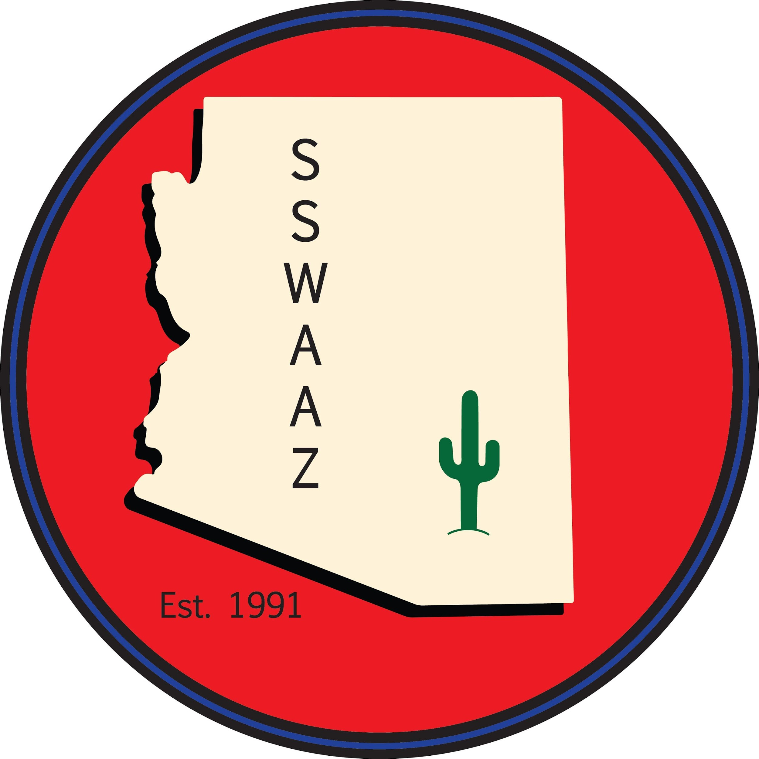
School Social Work Association of Arizona Annual Conference

March 5, 2021
The 2021 SSWAAZ Conference will be held Virtually

Call for Workshop Proposals

The 2021 Conference Committee welcomes proposals for virtual workshops that address the skills and competencies needed by school social workers and school service professionals in the context of the current educational environment and larger society

Suggested Topics for 2021 Conference Workshops
Our Members have expressed particular interest in topics including
• Ethics for Virtual School Social Work practice
• Equity and Diversity issues for 2020-2021
• PBIS/ MTSS Strategies
• Mindfulness Practices
• Synthetic and Recreational Drugs

● Virtual Interventions and tools for School Social Work
• Creative Therapeutic Interventions for individuals/groups
• Advocacy at the District and/or legislative levels
• Managing Difficult Behaviors in the Classroom
• Self Harm and Suicide Prevention

If you are interested in presenting a workshop, please complete the following:

Please PRINT or TYPE:

Name: __________________________________________________________________________________________

Address:___________________________________________ Phone: ( )___________________________________

School/Agency: ___________________________________________________________________________________

Phone: (____) ______________________ Fax: (____) ______________________E-mail: ________________________

●SSWAAZ will retain workshop proposals ● All workshops are 75 – 90 minutes in length ● Registration fees will be waived for presenters ●

Title of Proposed Workshop and Brief Abstract (30 words max)

Description of Proposed Workshop (100 - 200 words max)

This 2021 SSWAAZ Conference will be held virtually and will be utilizing ZOOM as our digital platform. Please share your experience/ comfort level in presenting in this format.

Please Return to: SSWAAZ P.O Box P.O. Box 12232 Chandler, Arizona 85248 or e-mail to sswaazboard@gmail.com

Proposals are due by November 29, 2020

SSWAAZ Selection Committee will notify presenters by December 13, 2020

